TECHNICAL REPORT ON STUDENT INDUSTRIAL WORK EXPERIENCE SCHEME (SIWES)

AT

ROYAL STONE GLOBAL INVESTMENT,
KADUNA, KADUNA STATE

FROM: 6TH OCTOBER, 2024
TO: 29TH JANUARY, 2025

TITLE PAGE

BY

FAISAL HUSSAINI
(SE/ARC/ND/23/016)

DEPARTMENT OF ARCHITECTURAL TECHNOLOGY, FEDERAL POLYTECHNIC MUBI, IN PARTIAL FULFILLMENT OF THE REQUIREMENT FOR THE AWARD OF NATIONAL DIPLOMA (ND) IN ARCHITECTURAL TECHNOLOGY

APRIL, 2025

DECLARATION
This is to declare that I, Faisal Hussaini with registration number SE/ARC/ND/23/016 undertook my four months SIWES at Royal Stone Global Investment, Kaduna, Kaduna State and have acquired all the experience compiled in this report in the course of my SIWES.

……………………………….. ……………………………
FAISAL HUSSAINI Sign/Date

CERTIFICATION
This is to certify that this report compiled by Faisal Hussaini (SE/ARC/ND/23/016) meets the requirements governing the award of National Diploma (ND) of the Federal Polytechnic Mubi, and is approved by:

………………………………. …………………………
Name of Supervisor Date
Departmental Supervisor

………………………………. …………………………
Arc. Daniel Barka Date
Departmental SIWES Coordinator

…………………………………. …………………………
Arc. Usman Mohammed Date
Head of Department

DEDICATION
I dedicate this technical report to my parents, my sisters and colleagues and to all those that supported me throughout my industrial training.

ACKNOWLEDGEMENTS
First of all, my sincere appreciation goes to Almighty God and salutation to my prophet.
I wish to thank all staff of Architectural Technology Department in Federal Polytechnic, Mubi.
My appreciation goes to my beloved parent for the motivation, prayers and financial support towards my SIWES exercise.
My special thanks go to my beloved brothers and sisters for all their care and support throughout my industrial training.
I want to also thank my colleagues and others; I really appreciate your efforts.

TABLE OF CONTENTS
TITLE PAGE i
DECLARATION ii
CERTIFICATION iii
DEDICATION iv
ACKNOWLEDGEMENTS v
TABLE OF CONTENTS vi
ABSTRACT viii
CHAPTER ONE 1
1.0 INTRODUCTION 1
1.2 AIMS AND OBJECTIVES OF SIWES 2
1.3 Brief history of SIWES and ITF in Nigeria 2
1.3 Significance of SIWES to students 3
CHAPTER TWO 4
2.1 BRIEF HISTORY OF ROYAL STONE GLOBAL 4
2.2 ORGANIZATIONAL CHART Error! Bookmark not defined.
CHAPTER THREE 4
3.0 DESCRIPTION OF WORK EXPERIENCE 5
3.1 SETTING OUT 5
3.2 BLOCK WORK 6
3.3 PLUMBING WORK 8
3.4 DEMOLITION OF BUILDING 10

CHAPTER FOUR 11
SUMMARY, CONCLUSION AND RECOMMENDATIONS 11
4.1 PROBLEMS OBSERVED DURING THE PROGRAMME 11
4.2 SUMMARY 11
4.3 CONCLUSION 12
4.4 RECOMMENDATIONS 12
REFERENCES 13

ABSTRACT
This report presents a comprehensive summary of the activities and experiences gained during my Students Industrial Work Experience Scheme (SIWES) at Royal Stone Global Construction Company. The report is divided into four chapters, beginning with an introduction to the SIWES programme, its history, objectives, and relevance to student development. Chapter Two covers the organizational profile of the host company, including its background, structure, and operations. The technical aspects of the training are detailed in Chapter Three, which discusses the practical work carried out—such as setting out, block work, demolition, and plumbing. The final chapter provides a summary of the entire experience, identifies the challenges encountered, and offers useful conclusions and recommendations. The training offered valuable exposure to real-life construction practices, workplace ethics, time management, and teamwork. It helped bridge the gap between academic theory and practical application, thereby equipping me with essential skills for future professional practice in the construction industry.

CHAPTER ONE

1.0 INTRODUCTION
SIWES was founded in 1973 by ITF (Industrial Training Funds) to address the problem of tertiary institution graduates' lack of appropriate skills for employment in Nigerian industries. The Students' Industrial Work Experience Scheme (SIWES) was founded to be a skill training programme to help expose and prepare students of universities, Polytechnics and colleges of education for the industrial work situation to be met after graduation. This system facilitates the transfer from the classroom to the workplace and aids in the application of knowledge. The program allows students to become acquainted with and exposed to the experience required in handling and operating equipment and machinery that are typically not available at their schools.
Prior to the establishment of this scheme, there was a rising concern and trend among industrialists that graduates from higher education institutions lacked appropriate practical experience for employment. Students who entered Nigerian universities to study science and technology were not previously trained in the practical aspects of their chosen fields. As a result of their lack of work experience, they had difficulty finding work. As a result, employers believed that theoretical education in higher education was unresponsive to the needs of labor employers. Thousands of Nigerians faced this difficulty till 1973. The fund's main motivation for establishing and designing the scheme in 1973/74 was launched against this context.
The ITF (Industrial Training Fund) organization decided to aid all interested Nigerian students and created the SIWES program. The federal government officially approved and presented it in 1974. During its early years, the scheme was entirely supported by the ITF, but as the financial commitment became too much for the fund, it withdrew in 1978. The National Universities Commission (NUC) and the National Board for Technical Education (NBTE) were given control of the scheme by the federal government in 1979. The federal government handed over supervision and implementation of the scheme to ITF in November 1984. It was taken over by the Industrial Training Fund (ITF) in July 1985, with the federal government bearing entire responsibility for funding.

1.2 AIMS AND OBJECTIVES OF SIWES
The Industrial Training Fund’s Policy Document No. 1 of 1973 which established SIWES outlined the objectives of the scheme as:
- Provide an avenue for students in Institutions of higher learning to acquire industrial skills and experience in their respective courses of study.
- Prepare students for the Industrial Work situation they are likely to experience after graduation.
- Expose students to work methods and techniques of handling equipment and machinery that may not be available in their Institutions.
- Make the transition from school to the world of work easier; and enhance students’ networks for later job placements.
- Provide students with an opportunity to apply their knowledge to real work situations, thereby bridging the gap between theory and practice; and vi. Enlist and strengthen Employers’ involvement in the entire educational process; thereby preparing the students for employment in Industry and Commerce.

1.3 Brief history of SIWES and ITF in Nigeria
It was said by Dr. Azikiwe Nnamdi, the one president of Nigeria that the practice of work but they all have the same goal that they all want to achieve in countries like china. They established within the premises of institution to provide real life situation, lack of practical skill of locally trained engineers and technologies. the chine way and condition of SIWES is that all institution must give student real life working experience in industrial works. Lecturers are involved in the industrial activities rendering constant services. So, all these countries have their own way of conducting the scheme but all lye on the same goal. And in Nigeria, the history of SIWES can be traced by the history of IITF which is the backbone of SIWES. ITF was established in 1974 under degree of 47 of 1971 (Edward, 2003). It was a body established by the Federal Government of Nigeria and was given responsibility of training indigenous Nigerians. The establishment of the body became necessary due to high demand of Nigeria to take up the vacant positions created in various sector of the economy after the colonial masters have departed. Therefore, the Federal Government discovered that it is easier to train students that are skilled in school to be trained and meet up with gaps in the Nigerian economy and a scheme was established to care for such training and it was named Student Industrial Work Experience Scheme (SIWES). In 1973, the National Board of Technical Education (NBTE) made it compulsory for all the polytechnic students, be it federal or state (Francis, 2012).

1.3 Significance of SIWES to students
Principles taught in the classroom are vein forced given concrete applications on the industrial assignment and students is able to see the relevance of their students which increase their motivation. It helps in given students the knowledge on the types of work to do after his/her graduation. SIWES given students opportunity for a change of environment as they move their institution to the place of attachment which changes the routine types of environment to a word of work. It helps in connecting the institution and the industrial their relationship the introduction of SIWES.

CHAPTER TWO

2.1 BRIEF HISTORY OF ROYAL STONE GLOBAL
Royal Stone Global Construction Company is a reputable and fast-growing construction firm established with the vision of delivering high-quality, innovative, and sustainable building solutions. Founded in the early 2000s, the company began as a small-scale contractor handling residential and commercial building projects. Through consistent performance, skilled manpower, and a commitment to excellence, Royal Stone Global rapidly expanded its operations across various states in Nigeria and other parts of West Africa.
Royal Stone Global Construction Company has also embraced the use of advanced technology, sustainable construction practices, and workforce development programs to stay ahead in the competitive industry. With a team of seasoned engineers, architects, and skilled workers, the company continues to play a significant role in shaping the built environment while maintaining strong client relationships and community impact.

2.2 ORGANIZATIONAL CHART
CHAIRMAN
MANAGING DIRECTOR
PROJECT MANAGER
CIVIL ENGINEER

BUILDING ENGINEER

SITE MANAGER
HUMAN RESOURCE
LABOURERS

STUDENTS
ACCOUNTANT
ADMINISTRATORS

Figure 2.1: Organogram

CHAPTER THREE

3.0 DESCRIPTION OF WORK EXPERIENCE

3.1 SETTING OUT
The Square Method was used to accurately set out rectangular or square buildings by ensuring all corners formed perfect right angles. It was based on the 3:4:5 rule from Pythagoras’ Theorem. The process involved measuring and pegging out straight lines, adjusting angles to form right corners, and confirming accuracy by checking diagonals. This method helped prevent construction errors and ensured the building's structural integrity. As noted by an engineer, accurate calculations during setting out were crucial for the building’s durability.
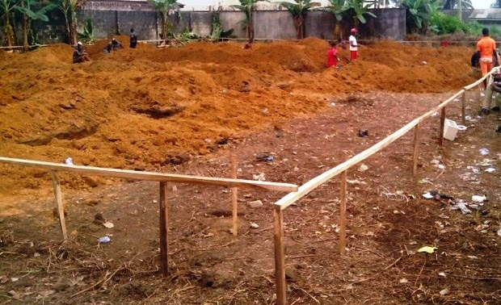
Plate 3.1: Setting out
Source: Author’s work, 2025

3.2 BLOCK WORK
During the block work stage of the construction project, I was actively involved in laying concrete blocks to form the walls and partitions of the building. This phase marked a significant part of the superstructure, where the shape and layout of the building began to take visible form.
The process started with setting out the block lines using a string line and spirit level to ensure straightness and level alignment according to the architectural drawings. A mortar mix of cement and sand was prepared in the appropriate ratio, usually 1:4 or 1:5, to achieve the required bonding strength.
I assisted in applying mortar on the base and sides of each block and carefully laid them along the guide lines. We maintained consistent joint thickness—typically 10mm—for both horizontal and vertical joints. A plumb bob and spirit level were used regularly to check vertical alignment and wall level as the blocks were laid in courses.
To ensure structural integrity, we installed reinforcement bars in block columns and at lintel levels where necessary, especially around door and window openings. We also made provisions for electrical and plumbing conduits by embedding pipes and boxes in the walls as required before the mortar set.
Curing was carried out by sprinkling water on the block walls daily to prevent premature drying and to enhance strength development. Openings for windows and doors were checked to match dimensions for frame installation. Through this hands-on experience, I gained valuable knowledge in masonry techniques, alignment accuracy, and the importance of proper curing and joint work in block construction.

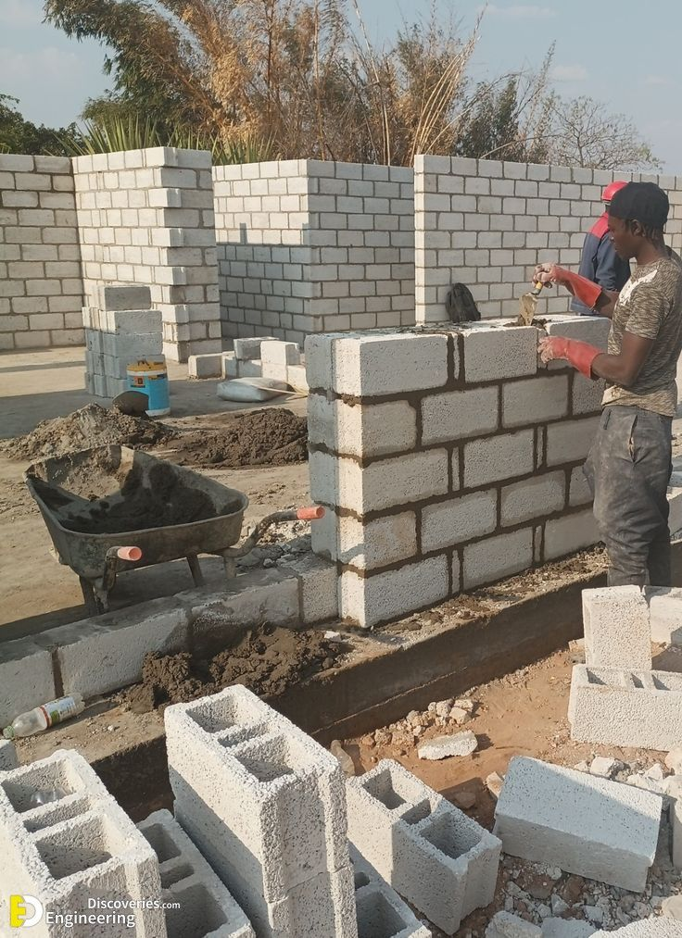
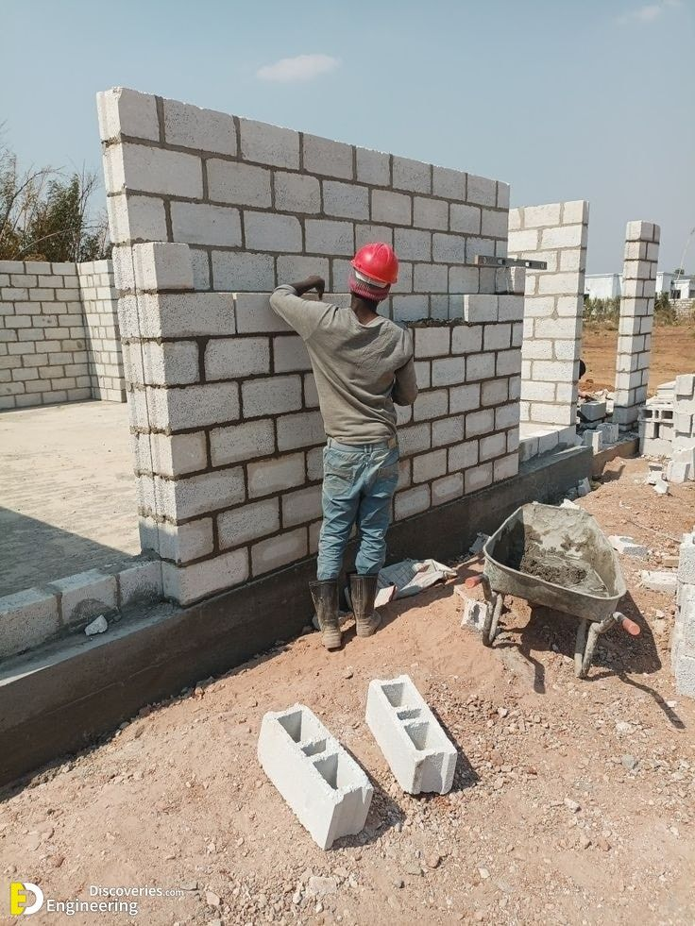
Plate 3.2: Block work
Source: Author’s work, 2025

3.3 PLUMBING WORK
During the course of the building project, I participated in plumbing activities, which involved the installation of water supply and drainage systems to ensure the effective distribution and disposal of water within the structure.
The plumbing work began with a detailed review of the plumbing layout as indicated in the building plan. This included identifying the points for water inlet, outlets, drainage lines, and connection to external water sources or septic systems. The plumber marked the pipe routes on the walls and floors, ensuring they aligned with the structural and architectural requirements.
I assisted in cutting and laying PVC pipes of various sizes for both cold and hot water lines, as well as drainage. These pipes were measured and cut accurately using a pipe cutter and joined using appropriate adhesives and fittings to ensure watertight connections. In some cases, elbows, tees, and valves were installed to allow for changes in direction or control water flow.
We also embedded pipes into the walls and floors before plastering and tiling works began. Great care was taken to ensure proper slopes were maintained in drainage pipes to allow smooth flow of wastewater and prevent blockages. Where necessary, pipe sleeves were provided at wall and floor intersections to allow for expansion and easy maintenance.
After completing the rough-in stage, a pressure test was conducted to check for leaks. Any identified leaks were fixed immediately before proceeding to the final stage of installing plumbing fixtures such as taps, water closets, washbasins, and kitchen sinks.
This experience gave me practical exposure to the importance of precision, system layout interpretation, and proper pipe handling in achieving a functional and durable plumbing system.

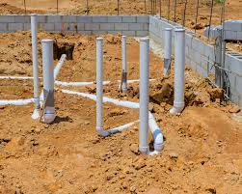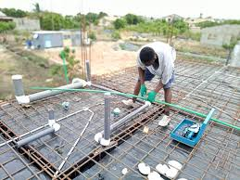
Plate 3.3: Plumbing work
Source: Author’s work, 2025

3.4 DEMOLITION OF BUILDING
During the initial site preparation phase, I was actively involved in the manual demolition of existing structures using basic tools such as pick axes and hammers. This task was essential for clearing the site and making way for new construction activities.
The demolition process began with a thorough inspection of the structure to be removed, ensuring that all safety precautions were in place. We wore personal protective equipment (PPE), including gloves, helmets, safety boots, and goggles, to protect ourselves from flying debris and falling materials.
Using the pick axe, we first created cracks and weakened specific areas of the structure, such as walls or concrete slabs, to make them easier to break apart. The hammer was then used to strike and chip away at the weakened parts. This manual approach allowed for controlled demolition, minimizing the risk of damaging nearby structures or underground utilities.
We worked systematically from top to bottom, carefully removing debris as we progressed to prevent accumulation and maintain a safe working environment. Rubble was gathered and transported to a designated disposal area or reused on-site as backfill material, depending on the project plan.
Participating in this activity enhanced my understanding of basic demolition techniques, safety practices, and the physical demands of construction work. It also taught me the importance of teamwork, attention to detail, and proper tool handling during site clearance operations.

CHAPTER FOUR

SUMMARY, CONCLUSION AND RECOMMENDATIONS

4.1 PROBLEMS OBSERVED DURING THE PROGRAMME
During the course of my SIWES programme, I encountered several challenges that affected the overall learning experience:
The duration of the programme was relatively short, which made it difficult to complete certain practical aspects thoroughly. There was no financial support provided by the company, which made daily transportation to and from the training site burdensome. Most of the workers did not offer adequate guidance or mentorship to the IT students. It was largely a self-driven learning environment where students had to ask questions or observe closely to learn anything.

4.2 SUMMARY
The Students Industrial Work Experience Scheme (SIWES) is an important platform designed to train and develop both the mind and body for efficient performance in the professional world. This programme effectively complements classroom-based theoretical learning with hands-on industrial exposure. Through participation in SIWES, students gain a better understanding of real-world industrial processes, including the importance of safety regulations, time management, teamwork, and quality control.
It offered me the opportunity to be actively involved in the daily operations of a professional work environment, thus preparing me for future responsibilities in the construction industry. The experience has broadened my perspective on the practical application of my academic knowledge.
To fully realize the benefits of the programme, it is crucial that input from Industrial Training Fund (ITF) coordinators and institutional supervisors is considered for continuous improvement.

4.3 CONCLUSION
The SIWES programme plays a crucial role in the academic and professional development of students, especially those in technical and engineering fields. It serves as a bridge between theoretical knowledge acquired in the classroom and the practical demands of real-life job environments. Beyond technical skills, it also encourages collaboration among students from various institutions and disciplines, fostering idea-sharing and teamwork.
Participating in the programme has given me firsthand exposure to construction processes, work ethics, and the importance of continuous learning in the field.

4.4 RECOMMENDATIONS
Based on my experience during the SIWES programme, I would like to make the following recommendations:
- Higher institutions should establish strong partnerships with companies and organizations in relevant industries to secure placement opportunities for students. This can also open doors for future employment opportunities.
- Students should approach the SIWES programme with a mindset focused on learning rather than financial gain. While stipends are beneficial, the skills and knowledge acquired are of far greater value in the long run.
- Orientation and mentorship programs should be introduced at the beginning of the SIWES placement to guide students on expectations, safety protocols, and learning objectives. This will help maximize the learning experience and ensure students are better integrated into the work environment.

REFERENCES
Adeyemi, M. B. (2007). Technical Education and Industrial Development in Nigeria. Journal of Educational Research and Development, 2(1), 45–52.
Akinboye, J. O. (2001). Guidance and Counselling: A Comprehensive Approach. Ibadan: University Press Limited.
ITF (Industrial Training Fund). (2013). SIWES Handbook: Student Industrial Work Experience Scheme. Jos: Industrial Training Fund Headquarters.
Ofoegbu, F. I. (2009). Industrial Training and National Development in Nigeria: The Role of SIWES. Nigerian Journal of Educational Administration and Planning, 9(2), 115–126.
Olaitan, S. O., Nwachukwu, C. E., Igbo, C. A., Onyemachi, G. A., & Ekong, A. O. (1999). Curriculum Development and Management in Vocational Technical Education. Onitsha: Cape Publishers International.

